This is the project on prediction the State and Region of Myanmar based on the town and village name.
The cleaned dataset include 19513 rows of state and town pair. Then the data is put into preprocessing state resulting in 19514x13003 . There are too many one hot encoded columns. There might be some problem with it .
Then the data is split into Train and Test and put into Model to train.

The original model consists of an input layer , two hidden layers of 32 neurons and 16 neurons respectively and finally an output layer.
Its parameter and summary are as follows

The initial layers results with

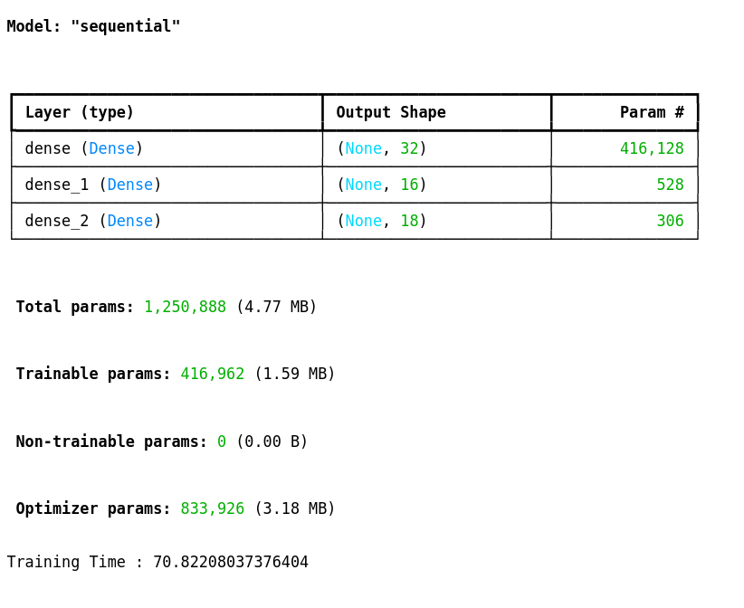

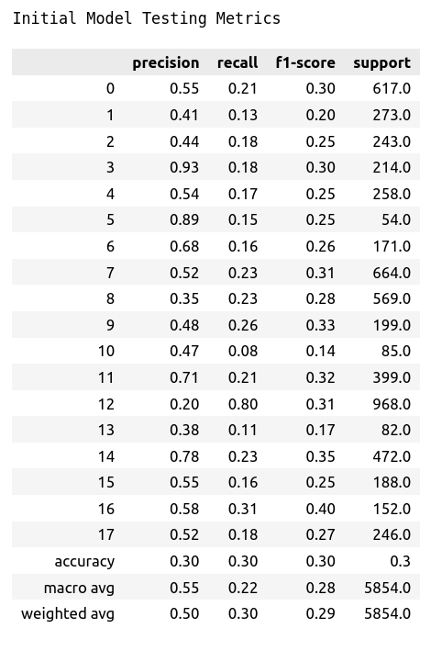
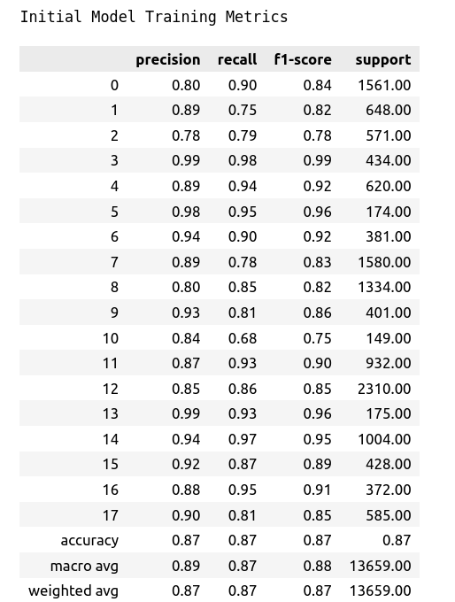

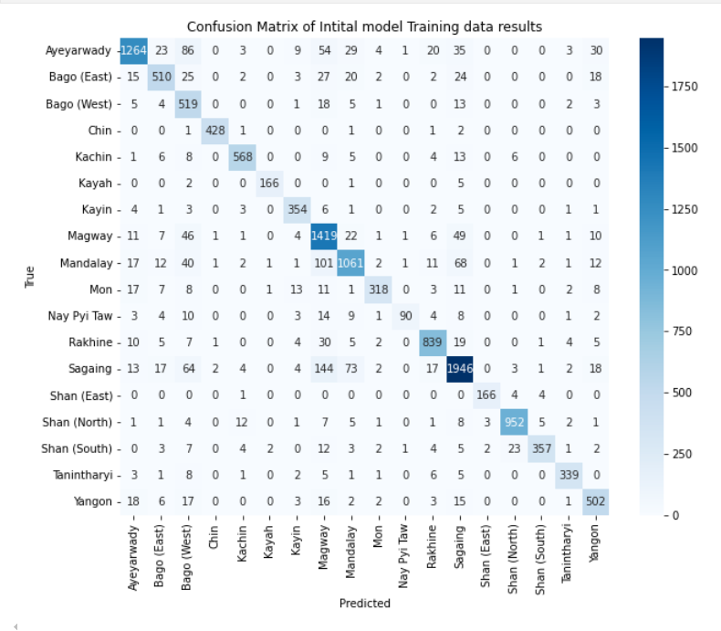
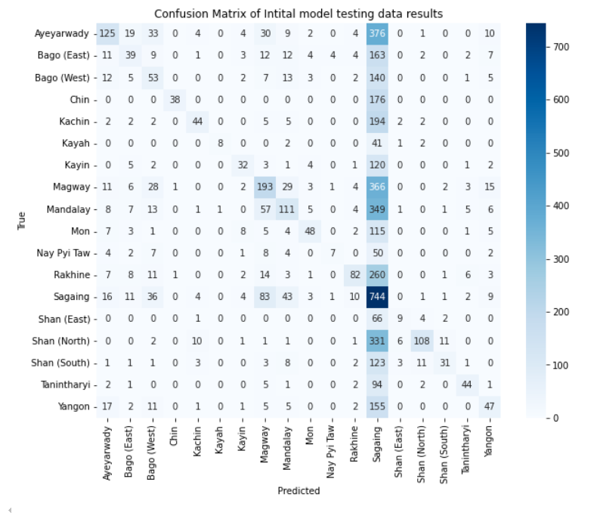

Looking at above classification metrics and confusion matrix , the model is overfitting a lot and there are a lot of confusion between classification especially on test dataset . Checking the class distribution, it seems that there is imbalances in the dataset.
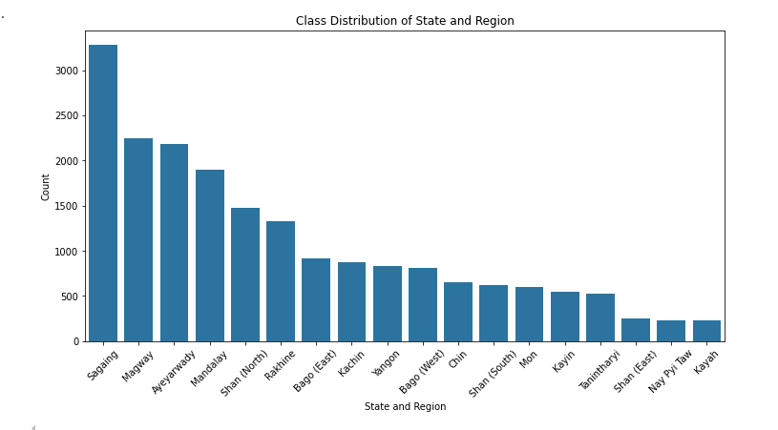

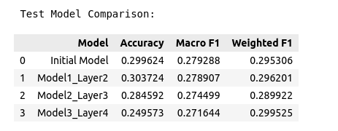
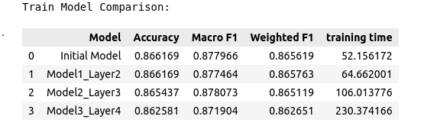
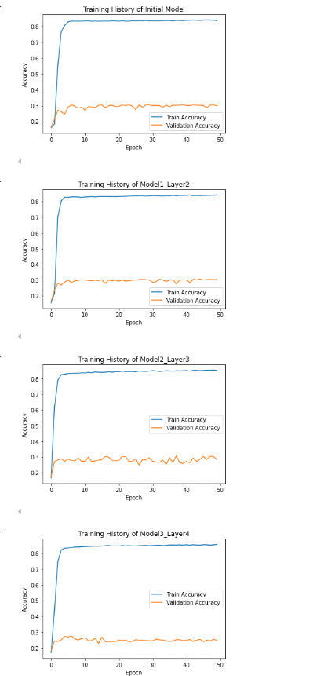

Multiple models with different layers and neurons were tested .

1. Model1_Layer2 with 64,32 neurons.
2.Model2_layer3 with 256,124,64 neurons.
3.Model3_Layer4 with 1024,256,124,64 neurons.

Increasing and reduction of layers and neurons, using other types of activation function are performed to check whether or not the performance can be improved.

It was found that beside increment of training time, the models aren’t learning properly ,no matter how many layers or neurons quantities were adjusted.

There was a lot of struggle finding errors for my analysis.
After searching for potential solution , it is found that with too much sparse one-hot encoded columns , the model can’t learn the relationship between features and class. The model should be using Embedded features instead of one-hot encoded model.
In conclusion, it is found that the right architecture and the right features are needed for the neural network to learn properly.

